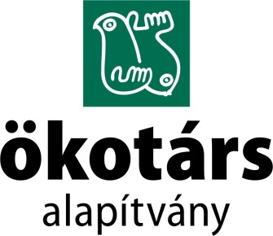

COMPLAINT FORM

In case if board members, employees, volunteers, trainees, interns, other individuals or organizations recognize any form of harm/abuse (or the risk of them) connected to work at Ökotárs it have be sign as soon as possible. The first sign (in oral or written form) must be taken to the Chairman of the Board to the Director of Ökotárs (in the following: Responsible).
Chairman of the Board: | Hartman Mátyás (Ökotárs Alapítvány)
Post address: | 1056 Budapest, Szerb u. 17-19.
E-mail address: | kuratórium@okotars.hu
Director: | Móra Veronika (Ökotárs Alapítvány)
Post address: | 1056 Budapest, Szerb u. 17-19.
E-mail address: | move@okotars.hu
Phone: | +36 1/411-3500

If you choose postal or personal delivery, please write to the envelope:

FOR THE BOARD or DIRECTOR.

Date of complainant:

- Details of the complainant
Name:
Phone number:
E-mail address:

- Details of the agrieved(s) (if they are not the same as the complainant)
Name:
Gender:
Age:
Availability:

- Details of the suspect(s)
Name:
Gender:
Age:
Availability:

- Case description
Location:
Date (If available, please provide the exact time.):
How did you find out about the case? (Please indicate the appropriate one.) | - I was a witness
 | - I was informed by the agrieved
 | - I learned from the potential suspect
 | - other:……………………………………………..
Please describe exactly what you are informed about.
Are you aware of other witnesses?

