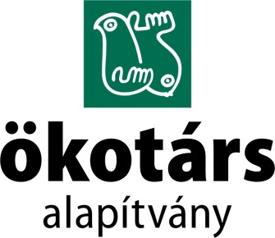

COMPLAINT FORM

In case of breach of equal treatment, harassment, unlawful separation, retaliation or other violations, the employee of the foundation (hereinafter referred to as the complainant) or the participant (or the complainant) involved in the program organized or conducted by the foundation before starting procedures under the applicable laws, in particular the Act CXXV of 2003 on equal treatment and the promotion of equal opportunities may contact the chairman of the Board via the publicly available complaint form on the foundation's website.

Head of the Board: | Hartman Mátyás (Ökotárs Alapítvány)
Post address: | 1056 Budapest, Szerb u. 17-19.
E-mail address: | kuratórium@okotars.hu
If you choose postal delivery, please write it on the envelope: FOR THE BOARD.

- Details of the complainant
Name:
Phone number:
E-mail address:

- Details of the agrieved(s) (if they are not the same as the complainant)
Name:
Gender:
Age:
Availability:

- Details of the violator(s)
Name:
Gender:
Age:
Availability:

- Case description
Location:
Date (If available, please provide the exact time.):
How did you find out about the case? (Please indicate the appropriate one.) | - I was a witness
 | - I was informed by the victim
 | - I learned from the offender
 | - other:……………………………………………..
Please describe exactly what you are informed about.
Are you aware of other witnesses?

